University of California D. Steigerwald
Department of Economics
Economics 241B

Exercise 2

1. Consider the bivariate regression model

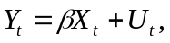

in which the regressor is exogenous and all observations are measured as deviations from means. You wish to test a hypothesis about the value of β with the OLS estimator B. Notation: There are n observations and 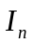 is the identity matrix of dimension n.

- A colleague tells you: “Always form the null hypothesis in such a way that rejecting the null hypothesis is of interest.” Do you think this advice is sensible?

This advice is sensible. We want to provide statistical evidence to reject a null hypothesis because most of the times it is easier to reject. In this case we do not accept the alternative hypothesis but reject the null given the evidence from the sample we extract.

b. To test hypotheses about β, the quantity of interest is the statistic

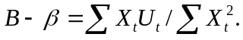

If we assume 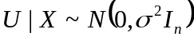, then what is the distribution of (B-β)|X? Does the distribution depend on X? Is the distribution exact, or does it hold only asymptotically?

- If the variance of (B-β)|X depends on parameters, construct a statistic (a function
- of B-β) whose variance does not depend on parameters (and so is a pivotal statistic). For the pivotal statistic you construct, give both the distribution conditional on X and the unconditional distribution. If σ² is unknown, we must use an estimator of σ² to form the statistic. Call the resulting statistic the estimated statistic. Does the distribution of the estimated statistic depend on X? For the estimated statistic, give both the conditional (on X) and unconditional distributions.

d. The Durbin-Watson statistic is

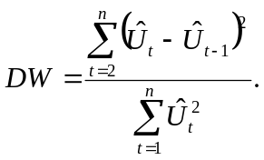

From your results in the preceding parts, what can you infer about the distribution, conditional on X, of DW? If the distribution of DW conditional on X depends on X, how does this affect the resultant critical values from the distribution?

2. You estimate the model
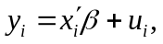

where  is the vector of regressors (including a constant) for observation i with 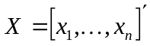. Let  be the OLS estimator of β.

a. Establish the truth, or falsehood, of each statement:
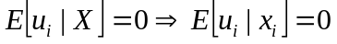
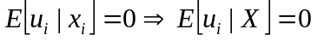.
Which of the assumptions is sufficient to establish that is unbiased? Derive the variance, and distribution of and determine which of the following assumptions is needed to do so:
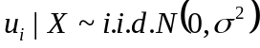
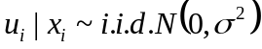.
Determine the smallest interval such that there is a 95 percent probability that lies in the interval (assume  is known).

b. Construct a 95 percent confidence interval for β. Why do we use the word confidence? Give an intuitive description of the relation between probability and confidence.

c. Consider the following axioms of probability:

(i) P(A) ≥ 0 for any event A in the sample space, S;
(ii) P(S) = 1.

If we interpret S as the parameter space, does the concept of confidence satisfy probability axioms (i) and (ii)? (For example, if Φ is the parameter space, does C(Φ) equal one?) Carefully explain your answer.

d. The probability interval defined in part a is uniquely derived from the probability distribution of B. From the confidence interval in part b, is it possible to uniquely derive a confidence distribution for β? Provide an example to support your argument.

3. Hypothesis Testing and Standard Error Estimation

You are helping to assess the accuracy of a report on anti-crime efforts. To reduce crime, the city council funded a community policing initiative and additional after-school programs. Five years have passed and the council has asked a consultant to analyze the effectiveness of the programs on reducing crime. The consultant gathered monthly crime statistics for the past 10 years (including the 5 years before the anti-crime efforts began) and regressed the crime rate on city characteristics (such as age and income), economic conditions (such as the unemployment rate) and measures of the funding of the anti-crime programs. In the report to the city council, the consultant defined
β₁ coefficient on community police funding
β₂ coefficient on after-school program funding
and found
β₁=-2.2 with estimated standard error of 1.0
β₂=-4.0 with estimated standard error of 1.5
R²=.87.

a. The consultant begins by stating that the estimates show that both programs are effective at reducing crime, based on the fact that the point estimates are more than 1.95 times their estimated standard errors. Under questioning, the consultant tells the council that the value 1.95 comes from a normal distribution. One of the council members states that she read that the appropriate distribution is really a t distribution and so the analysis is flawed. The council turns to you to resolve the issue. Please respond.

b. A member of the audience, who has been listening to the discussion, interjects that one needs to know how the estimated standard errors are calculated. The consultant responds that the estimated standard errors assume the errors are homoskedastic and uncorrelated. The audience member states that only a fool would make such an assumption, the consultant in a heated response states that the assumption doesn't really affect the conclusion. The council turns to you to sort out this argument. Please respond.

c. After everyone has calmed down, the consultant resumes the analysis. But before much more can be reported, the president of the local statistical society responds that the correct way to determine the effectiveness of the programs cannot be accomplished simply by looking at each program individually, one must examine both programs together. Apparently satisfied, the president sits down without further explanation. Both the consultant and the council now turn to you to help make sense of this. Please respond.

4. Computational Exercise

Read through the paper by Charness and Kuhn listed on the syllabus. Write programs in both Matlab and Stata (the results from each program should match) that estimate the model in columns (1), (2) and (3) of Table 3 of Charness and Kuhn. Calculate classic standard errors (the authors report cluster-robust standard errors, so your estimated standard errors will not match those in the table). Finally, for the models of columns (2) and (3) test the hypothesis that the coefficient on relative wage equals zero and provide the p-value for the estimated test statistic.

The key variables:
e1 - effort of type 1 workers
w1 - wage of type 1 workers
w2 - wage of type 2 workers

For help with Stata programming, consult the reference by Cameron and Trivedi.
For Matlab programming: Matlab files are denoted .m and there are certain naming conventions to follow. To determine these, use Matlab help to search “filenames” and then follow the link to naming m files.

Notation to begin:
% denotes a comment to follow
; denotes the output of the line should not be printed

Commands to study
clc
clear
xlsread
plot

Sample Program
% Program Title
% Date created

clc;
clear all; % to ensure a clear workspace before you begin

data=xlsread(‘dataset’); % to read in data

q=data(1:92,1); % define quantity

plot(q, ‘d’); % plot for outliers

